**Modification Log**

|  |  |  |  |
| --- | --- | --- | --- |
| **Version** | **Modification date** | **Author** | **Comments** |
| 1.0 | July 4, 2016 | Evan Situ |  |
| 1.1 | August 29, 2016 | Evan Situ | Added section 6 and 8 and 1.4 |
| 1.2 | September 13, 2016 | Evan Situ | Added 9. Updating a Global Variable |
| 1.3 | September 16, 2016 | Evan Situ | Added Section 10 Force Check-In |

Contents

[1. Pre-requisites 2](#_Toc461788684)

[2. Add User 3](#_Toc461788685)

[3. Assign User to Process 3](#_Toc461788686)

[4. Start New Academic Year 4](#_Toc461788687)

[5. Historical Program Measurement Archive 6](#_Toc461788688)

[6. Historical Program Measurement Report 7](#_Toc461788689)

[7. Add New Course to the Process 8](#_Toc461788690)

[8. Edit Courses and Programs Mapping 10](#_Toc461788691)

[9. Updating a Global Variable 11](#_Toc461788692)

[10. Force Check-In 13](#_Toc461788693)

[11. Other Vena Resources 14](#_Toc461788694)

# Pre-requisites

1. Admin access to McMaster Vena to Add or Remove user.
2. Modeler/Admin access to run the ETL (Extract, Transform and Load) process
3. “AcademicYearTemplate.csv” to pass parameter into the ETL process
4. Annual Timeline

|  |  |  |  |  |
| --- | --- | --- | --- | --- |
| **Date** | **Task** | **Section Guide** | **Template** | **Task Owner** |
| Early Summer | Archive previous year data | A5 |  | Assoc Dean |
| Summer | Data copied over to next academic year | A4 |  | Assoc Dean |
| Summer | Update global variable to the new year and term | A9 | Input Variables Template | Assoc Dean |
| Summer | Add new courses | A7 |  | Assoc Dean, Department |
| Summer | Changes to programs (mapping b/w courses and programs) | D5 |  | Department |
| Summer | Assign instructors to courses | ? | Template discussed on Sept 26 | Department |
| Summer | Curriculum mapping, will require consultation and verification with Instructors | D2.3 | Curriculum Mapping Input Template | Department Attributes Committee |
| Summer | Measurement mapping | D2.2 | Measured Indicators Input Template | Department Attributes Committee |
| Aug/Sep | Instructor reviews continuous improvement plan from the previous year | I3.1 | Curriculum Committee Recommendations Report (Previous Year) | Instructor |
| Jan | Instructor enters rubric and their continuous improvement plan for Term 1 | I2 | Rubric Input Template, Course Report | Instructor |
| March | Update global variable for the new term (after Term 1 data entry is complete) | A9 | Input Variables Template | Assoc Dean |
| Dec/Jan | Instructor reviews continuous improvement plan from the previous year | I3.1 | Curriculum Committee Recommendations Report (Previous Year) | Instructor |
| Early May | Instructor enters course reports for Term 2 | I2 | Rubric Input Template, Course Report | Instructor |
| May | Curriculum committees review course reports, generate continuous improvement plan report | I4, D3 | Course Report, Curriculum Committee Recommendations Input Template | Department |
| June | Meeting of continuous improvement committee (external advisors students) |  |  | Department |
| June | Departments plan curriculum revisions |  |  | Department |
| September | Faculty reviews departmental committee reports, writes report |  | ? | Faculty |
| All Year | Add/Remove manage users | A2 |  | Assoc Dean? |
|  | View Historical Data | A6 |  |  |
|  | Assign Users to Process | A3 |  |  |

# Add User

* 1. Login to <https://us1.vena.io/administrator>
  2. Under “Admin” 🡪 “Users” 🡪 “Add User”

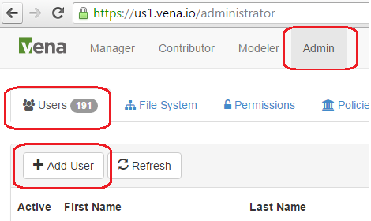

* 1. Fill in the user information and select the login types 🡪 Click “Save”

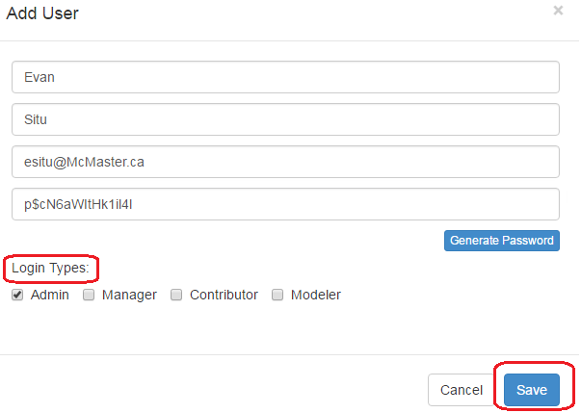

# Assign User to Process

* 1. After login to Vena 🡪 Under “Manager”🡪Click “Designer”🡪Click on the task or activities you want to assign user.

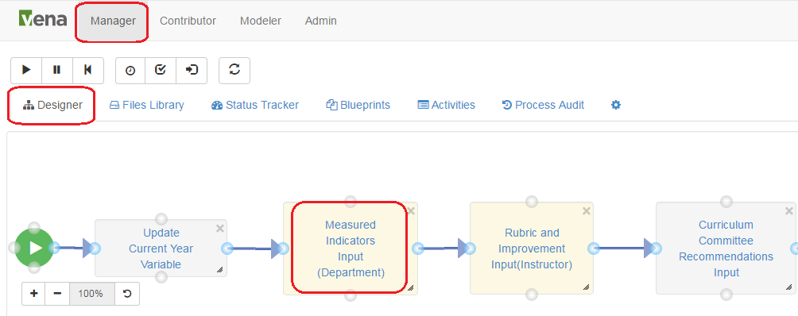

* 1. Double Click on the Task 🡪on the “Task Detail” windows 🡪 Click “Users”🡪Type the User name that you want to add (you can add users to different role in the process (Owners, Support Workers, Watchers), please refer to the detail documentation for the different of each role 🡪 Click “Save”

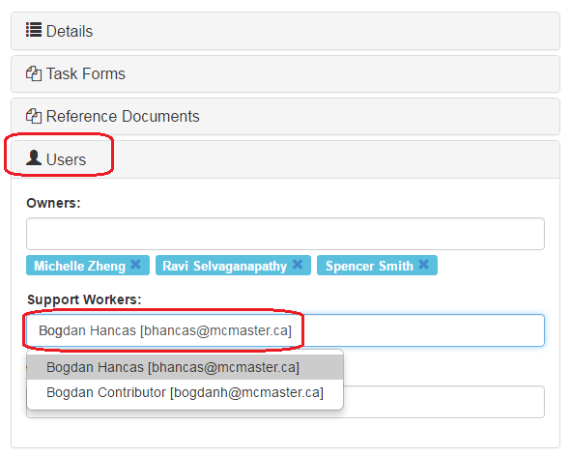

# Start New Academic Year

* 1. Since current year’s curriculum mapping, measured as well as Rubric information will be used as of the starting for new academic year. An automated ETL process in Vena is built to accomplish this task.
  2. Open the input template “AcademicYearTemplate.csv” 🡪enter the new academic year data in cell “A1” (format yyyy-yyyy) 🡪 Save

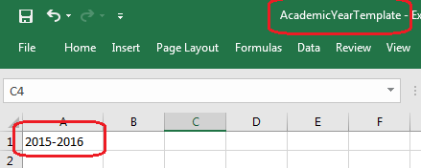

* 1. Click on “Modeler” 🡪 “Data Modeler” 🡪 “ETL” 🡪 “Import”🡪Click the “Run” button () on “New Academic Year”

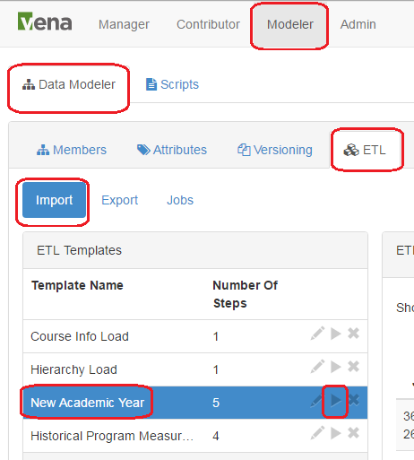

* 1. On the open windows, click “Choose File”🡪select the “AcademicYearTemplate.csv” from step 2 🡪 Click “Import”

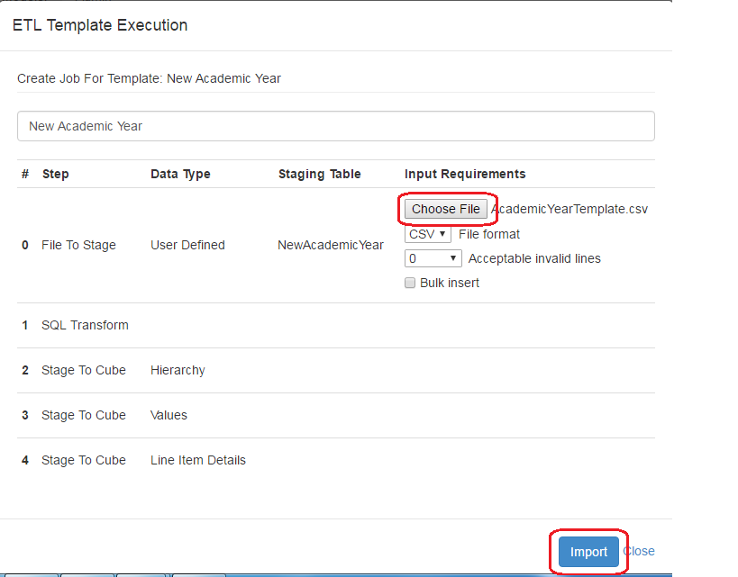

* 1. You will now see the ETL Status “RUNNING” 🡪 once the ETL job completed, the status will become “COMPLETED” (it will take about 5-10 minutes to complete the ETL job, you can click the refresh bottom at above the “Status” to refresh)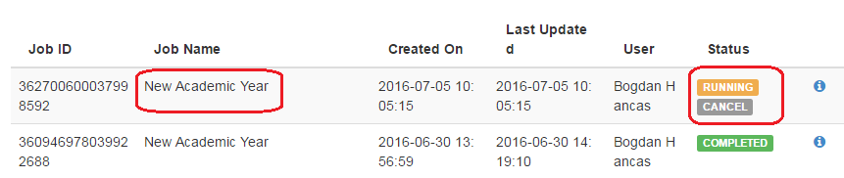

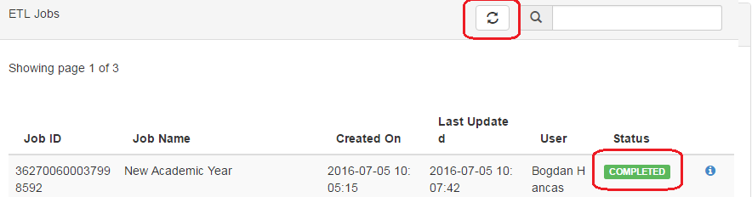

* 1. After the ETL completed, you should see the data appear under the “Year” dimension

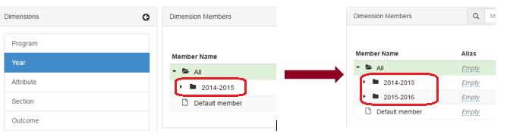

# Historical Program Measurement Archive

* 1. Please only archive the program measurement when the program is fully completed. The purpose of archive the program measurement data is to track the historical trend of a program.
  2. The purpose of archiving the data is so that the historical program measurement report can be generated.
  3. Open the input template “AcademicYearTemplate.csv” 🡪enter the new academic year data in cell “A1” (format yyyy-yyyy) 🡪 Save



* 1. Click on “Modeler” 🡪 “Data Modeler” 🡪 “ETL” 🡪 “Import”🡪Click the “Run” button () on “Historical Program Measurement Archive”

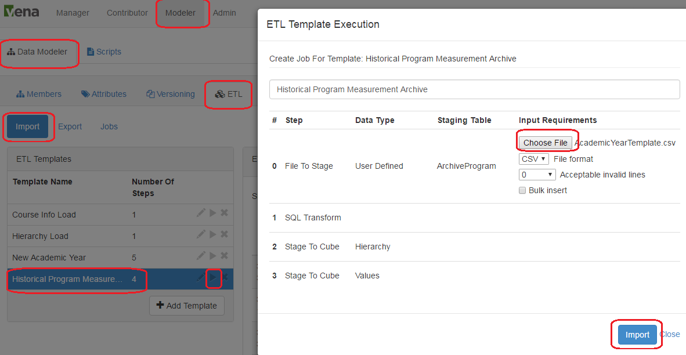

* 1. You will now see the ETL Status “RUNNING” 🡪 once the ETL job completed, the status will become “COMPLETED” (it will take about 5-10 minutes to complete the ETL job, you can click the refresh bottom at above the “Status” to refresh)

# Historical Program Measurement Report

Once the archive completed, the historical program data will be available in the “Historical Program Measurement Report”. (The historical program measurement report will not work for any year’s data that has not yet been archived.)

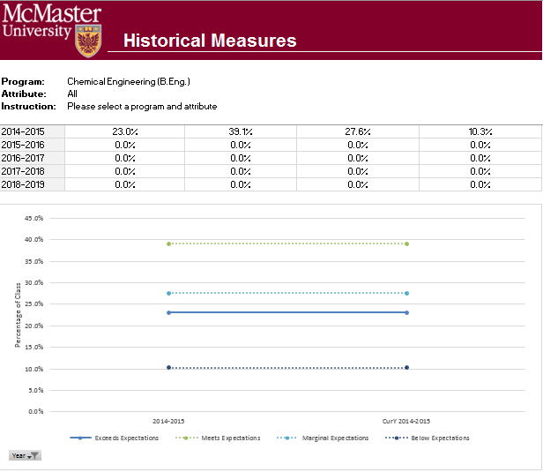

# Add New Course to the Process

* 1. Use blueprints to create a new course will be an easier option🡪Login to Vena🡪Click on use blueprints to create activity icon

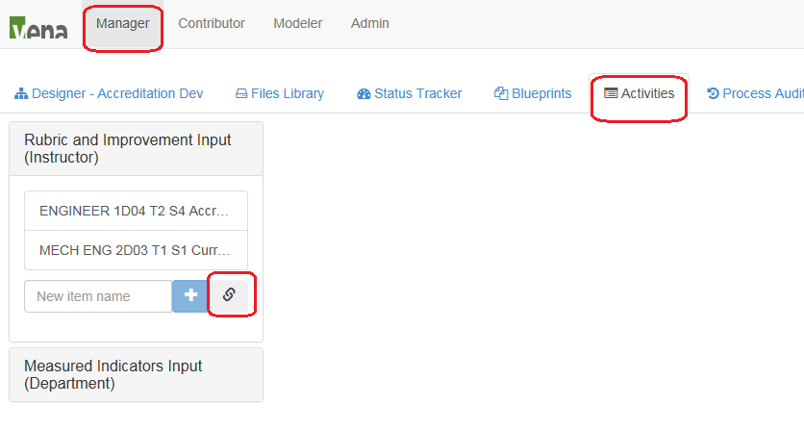

* 1. Select the blueprint “Instructor Accreditation Process”
  2. Double click on task “Complete Rubric”

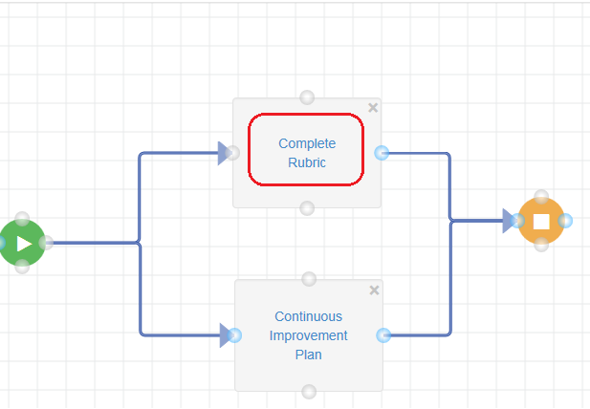

* 1. Under “Details”, enter the instructions and due date 🡪Under task forms, attach the “Rubric input template”🡪under users, assign owners and support workers to this task.

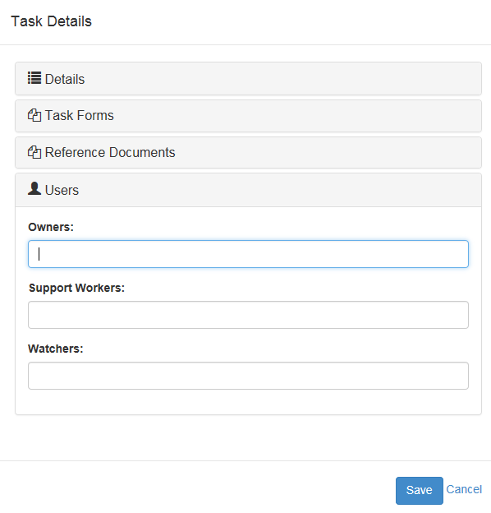

* 1. Rename the process by click on rename icon and enter the name

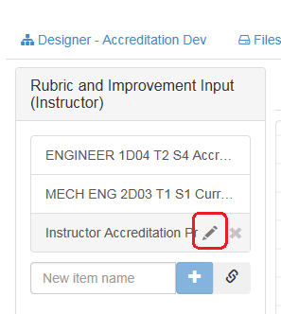

# Edit Courses and Programs Mapping

* 1. Login Vena as Modeler or Admin
  2. Click on “Modeler” at the top navigation bar
  3. Click on “Program” at the left navigation bar
  4. Expand the “Member Name” 🡪Right Click at a course or program you would like to move🡪Click “Cut” 🡪Select destination parent member🡪Right Click then choose “Paste”
  5. The above process can also be done by dragging and dropping the child member to the parent member

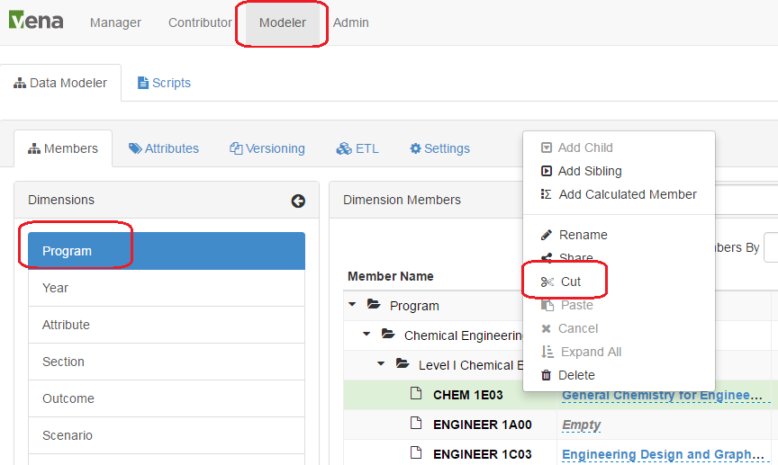

# Updating a Global Variable

Below are the steps to successfully update a Global Variable:

(Updated the term global variable will help to prevent enter the incorrect term/year in the input templates)

* 1. Open your Vena Global Variable template “Input Variables Template” (you are find this template at Manager🡪Files Library

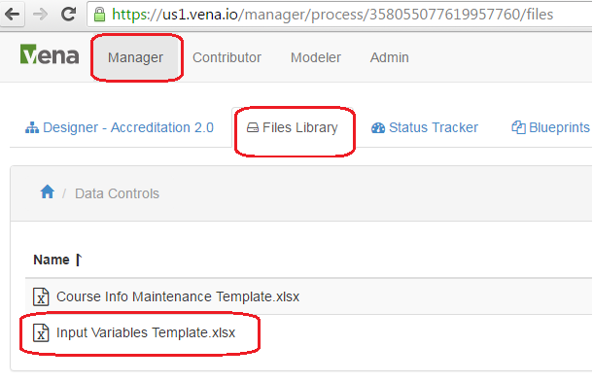

* 1. Select the cell with the value of the Global Variable 🡪Click “Edit Template”

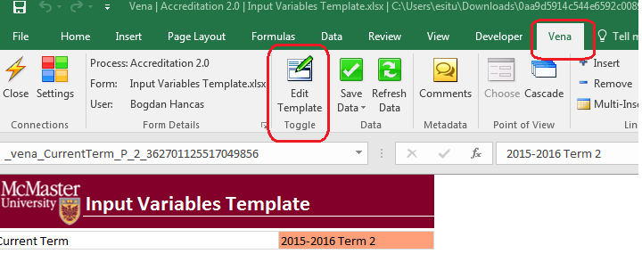

* 1. Click on Add/Edit Variable -> Metadata (must be in Edit Template mode)

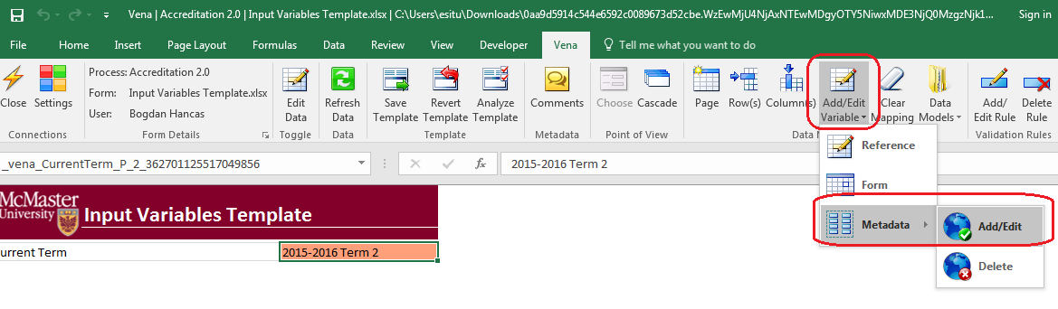

* 1. Update the respective variable with the new member (only a single member can be in a global variable)

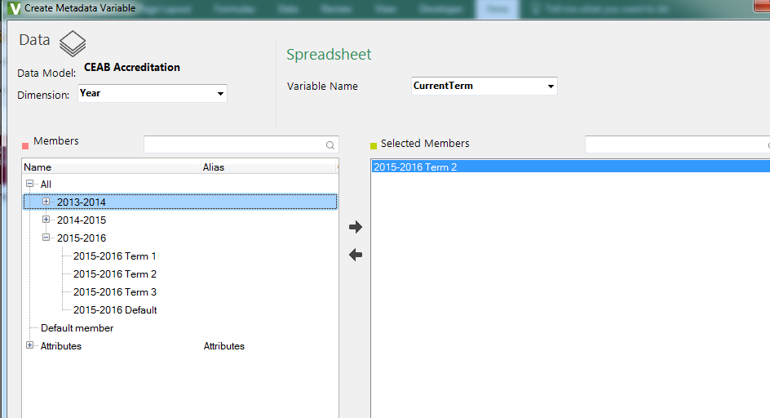

* 1. Close the variable window and Save Template

# Force Check-In

A task has been checked out by a user who is unavailable and it needs to be checked back in. Please follow the following steps.

* 1. Login as a manager
  2. Go to Status Tracker
  3. Find the checked-out task assigned to the user
  4. Right click on the status of the task and hit Force Check-In

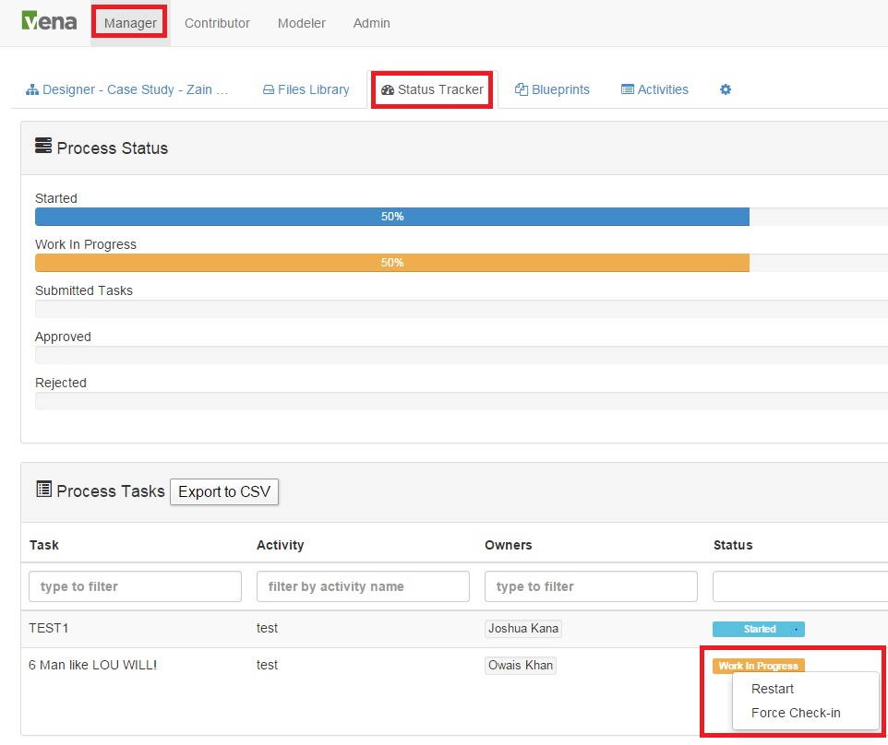

# Other Vena Resources

* 1. For detail documentation, please refer to the precious document.
  2. For Vena training or user manual, please refer to <http://docs.vena.io/>
  3. For other helps please contact:
* Bogdan Hancas: [bhancas@venasolutions.com](mailto:bhancas@venasolutions.com" \t "_blank)
* Evan Situ: [esitu@venasolutions.com](mailto:esitu@venasolutions.com)